CS 449 Sprint 2 Report
Peg Solitaire BrainVita
Student | Student ID | Submission date
Devan Sai D | 16404909 | October 27, 2026

For Sprint 2, I completed the gameplay rules and game-over behavior for Peg Solitaire BrainVita in Java. The English, Hexagon, and Diamond layouts and their size choices were carried forward from the earlier sprint. This report focuses on making valid and invalid moves, detecting both ways a game can end, assigning the final rating, and verifying those requirements with JUnit 5 tests.
GitHub repository: https://github.com/devansai10/cs449-peg-solitaire
Demonstration video: [PASTE PUBLIC YOUTUBE OR PANOPTO LINK HERE]

1 Demonstration
I will use the following order in my video so I can show the main features and the test results within the three-minute limit.
Time | Feature | What to demonstrate
0:00-0:20 | Sprint 2 scope | Explain that board choices were carried forward and that Sprint 2 adds gameplay and game-over behavior.
0:20-0:45 | Open a sample game | Start English size 7 and show 32 pegs, an empty center, and zero moves as the test setup.
0:45-1:25 | Make moves | Complete one legal move and attempt one invalid move that leaves the board and counters unchanged.
1:25-1:55 | Game over | Explain the one-peg finish, the no-legal-moves finish, and the remaining-peg rating.
1:55-3:00 | Automated tests | Run mvn clean test and show 16 passing tests and BUILD SUCCESS.

2 Summary of Source Code
My project has four production classes and three test classes. The line counts below include code, comments, and blank lines.
Source code file | Classification | Lines
BoardShape.java | Production | 45
PlayerRating.java | Production | 17
SolitaireGame.java | Production | 123
SolitaireApp.java | Production | 190
PlayerRatingTest.java | Test | 40
SolitaireGameTest.java | Test | 113
Sprint2AcceptanceTest.java | Test | 108
TOTAL | 375 production + 261 test | 636

Design Responsibilities
Class | Responsibility
BoardShape | Defines playable positions for English, Hexagon, and Diamond layouts.
SolitaireGame | Owns board state, move validation, move execution, legal-move search, and game-over detection.
PlayerRating | Converts a positive remaining-peg count to Outstanding, Very Good, Good, or Average.
SolitaireApp | Builds the Swing interface, reads player selections, starts games, and renders model state.

3 Production Code vs User Stories and Acceptance Criteria
The Sprint 2 work is organized into the two required user stories below. Each acceptance criterion is written so it can be checked directly in the implementation and in JUnit.

User Story 1 Make a Move in a Game
As a player, I want to make a move in the game so that I can remove pegs and continue playing.
AC | Given When Then | Implementation | Status
1.1 | Given a game is in progress at any point during play and a peg can jump horizontally, vertically, or diagonally over one adjacent peg into an empty playable hole exactly two positions away, when I make that move, then the starting hole and jumped hole become empty, the destination contains the moving peg, the peg count decreases by one, the move count increases by one, and every other position stays unchanged. | SolitaireGame.isLegal(); SolitaireGame.move(); SolitaireApp.select() | Complete
1.2 | Given a selected move does not satisfy the jump rules, when I attempt the move, then it is rejected and the board, peg count, and move count remain unchanged. | SolitaireGame.isLegal(); SolitaireGame.move(); SolitaireApp.select() | Complete

User Story 2 Determine When the Game Is Over
As a player, I want the game to determine when it is over so that I can see my final result and rating.
AC | Given When Then | Implementation | Status
2.1 | Given a legal move leaves one peg on the board, when that move is completed, then the game ends, no further move is accepted, and the result is Outstanding. | SolitaireGame.isOver(); SolitaireGame.result(); PlayerRating.rate(); SolitaireApp.update() | Complete
2.2 | Given more than one peg remains, when no legal horizontal, vertical, or diagonal move is available anywhere, then the game ends and the rating is Very Good for 2 pegs, Good for 3 pegs, or Average for 4 or more pegs. | SolitaireGame.legalMoves(); SolitaireGame.isOver(); SolitaireGame.result(); PlayerRating.rate() | Complete

4 Tests vs User Stories and Acceptance Criteria
I ran the full Maven and JUnit 5 suite again on October 27, 2026. All 16 tests passed with no failures, errors, or skipped tests.

4.1 Automated Tests Directly Corresponding to the Acceptance Criteria
The table below connects every acceptance criterion to the exact test class and method that verifies it.
User Story ID and Name | AC ID | Test Class Name | Test Method Name | Status
1 Make a Move in a Game | 1.1 | SolitaireGameTest | orthogonalMoveRemovesExactlyTheJumpedPeg(); diagonalMoveIsAllowedByTheCourseRules() | Pass
1 Make a Move in a Game | 1.2 | SolitaireGameTest; Sprint2AcceptanceTest | invalidMovesDoNotChangeBoardOrMoveCount(); invalidJumpLeavesEveryCellUnchangedAndAllowsRecovery() | Pass
2 Determine When the Game Is Over | 2.1 | Sprint2AcceptanceTest; PlayerRatingTest | onePegFinishIsOutstanding(); onePegReceivesOutstanding() | Pass
2 Determine When the Game Is Over | 2.2 | Sprint2AcceptanceTest; PlayerRatingTest | deterministicGameEndsAndRejectsFurtherMoves(); twoPegsReceiveVeryGood(); threePegsReceiveGood(); fourOrMorePegsReceiveAverage() | Pass

4.2 Manual Tests Directly Corresponding to the Acceptance Criteria
No acceptance criterion depends only on a manual test. All four criteria are automated in Section 4.1. The narrated video still demonstrates one legal move and one invalid move through the GUI as supporting evidence.
User Story ID and Name | AC ID | Test Case Input | Expected Output | Notes
Not applicable | N/A | No separate manual-only test input | All acceptance criteria are verified by JUnit 5 tests in Section 4.1. | The GUI demonstration supplements the automated results.

4.3 Other Automated or Manual Tests
These tests check carried-forward features, input boundaries, and broader regression behavior beyond the four acceptance criteria above.
Number | Test Input | Expected Result | Test Class Name | Test Method Name
1 | English, Hexagon, and Diamond boards in sizes 7 and 9 | Each layout starts with the required peg count, an empty center, zero moves, and no result. | SolitaireGameTest | everyLayoutStartsWithOnlyItsCenterEmpty()
2 | Unsupported sizes -1, 0, 6, 8, and 100 | The constructor throws IllegalArgumentException. | SolitaireGameTest | unsupportedSizesAreRejected()
3 | A moved English size 7 game followed by a new Diamond size 9 model | The new model has fresh state while the earlier game remains unchanged. | Sprint2AcceptanceTest | restartingWithSelectedBoardResetsMovesAndCenter()
4 | Zero and negative peg counts | PlayerRating rejects invalid counts with IllegalArgumentException. | PlayerRatingTest | zeroPegsAreRejected(); negativePegsAreRejected()
5 | Seeded complete games on every supported layout and size | Every game terminates, preserves the peg-count invariant, and returns the correct rating. | SolitaireGameTest | completeGamesTerminateAndKeepValidCountsAcrossAllLayouts()

5 Verification Evidence

5.1 Maven and JUnit Results
I ran mvn clean test with Java 21 after finishing the Sprint 2 changes. Maven compiled all four production files and all three test files. The results are shown below.
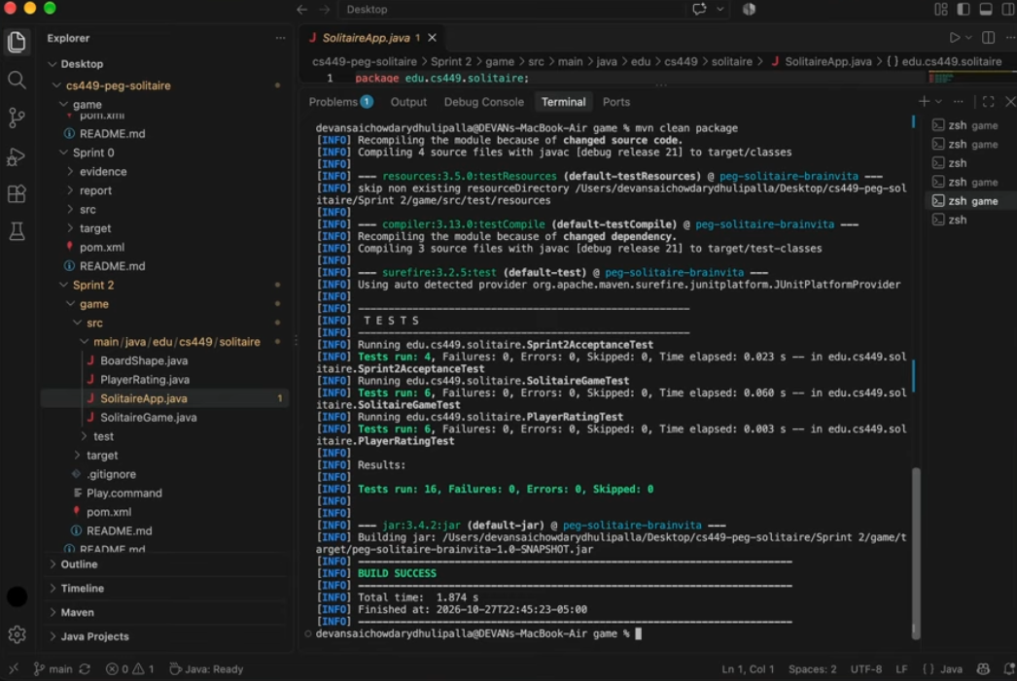
Figure 1. Fresh Maven run on October 27, 2026: 16 tests passed and BUILD SUCCESS.

5.2 Graphical Interface
The GUI lets the player choose a board type and size, start a new game, and turn move hints on or off. It also shows the peg count, move count, and current status. Move validation and game-over decisions come from the SolitaireGame model rather than the interface.
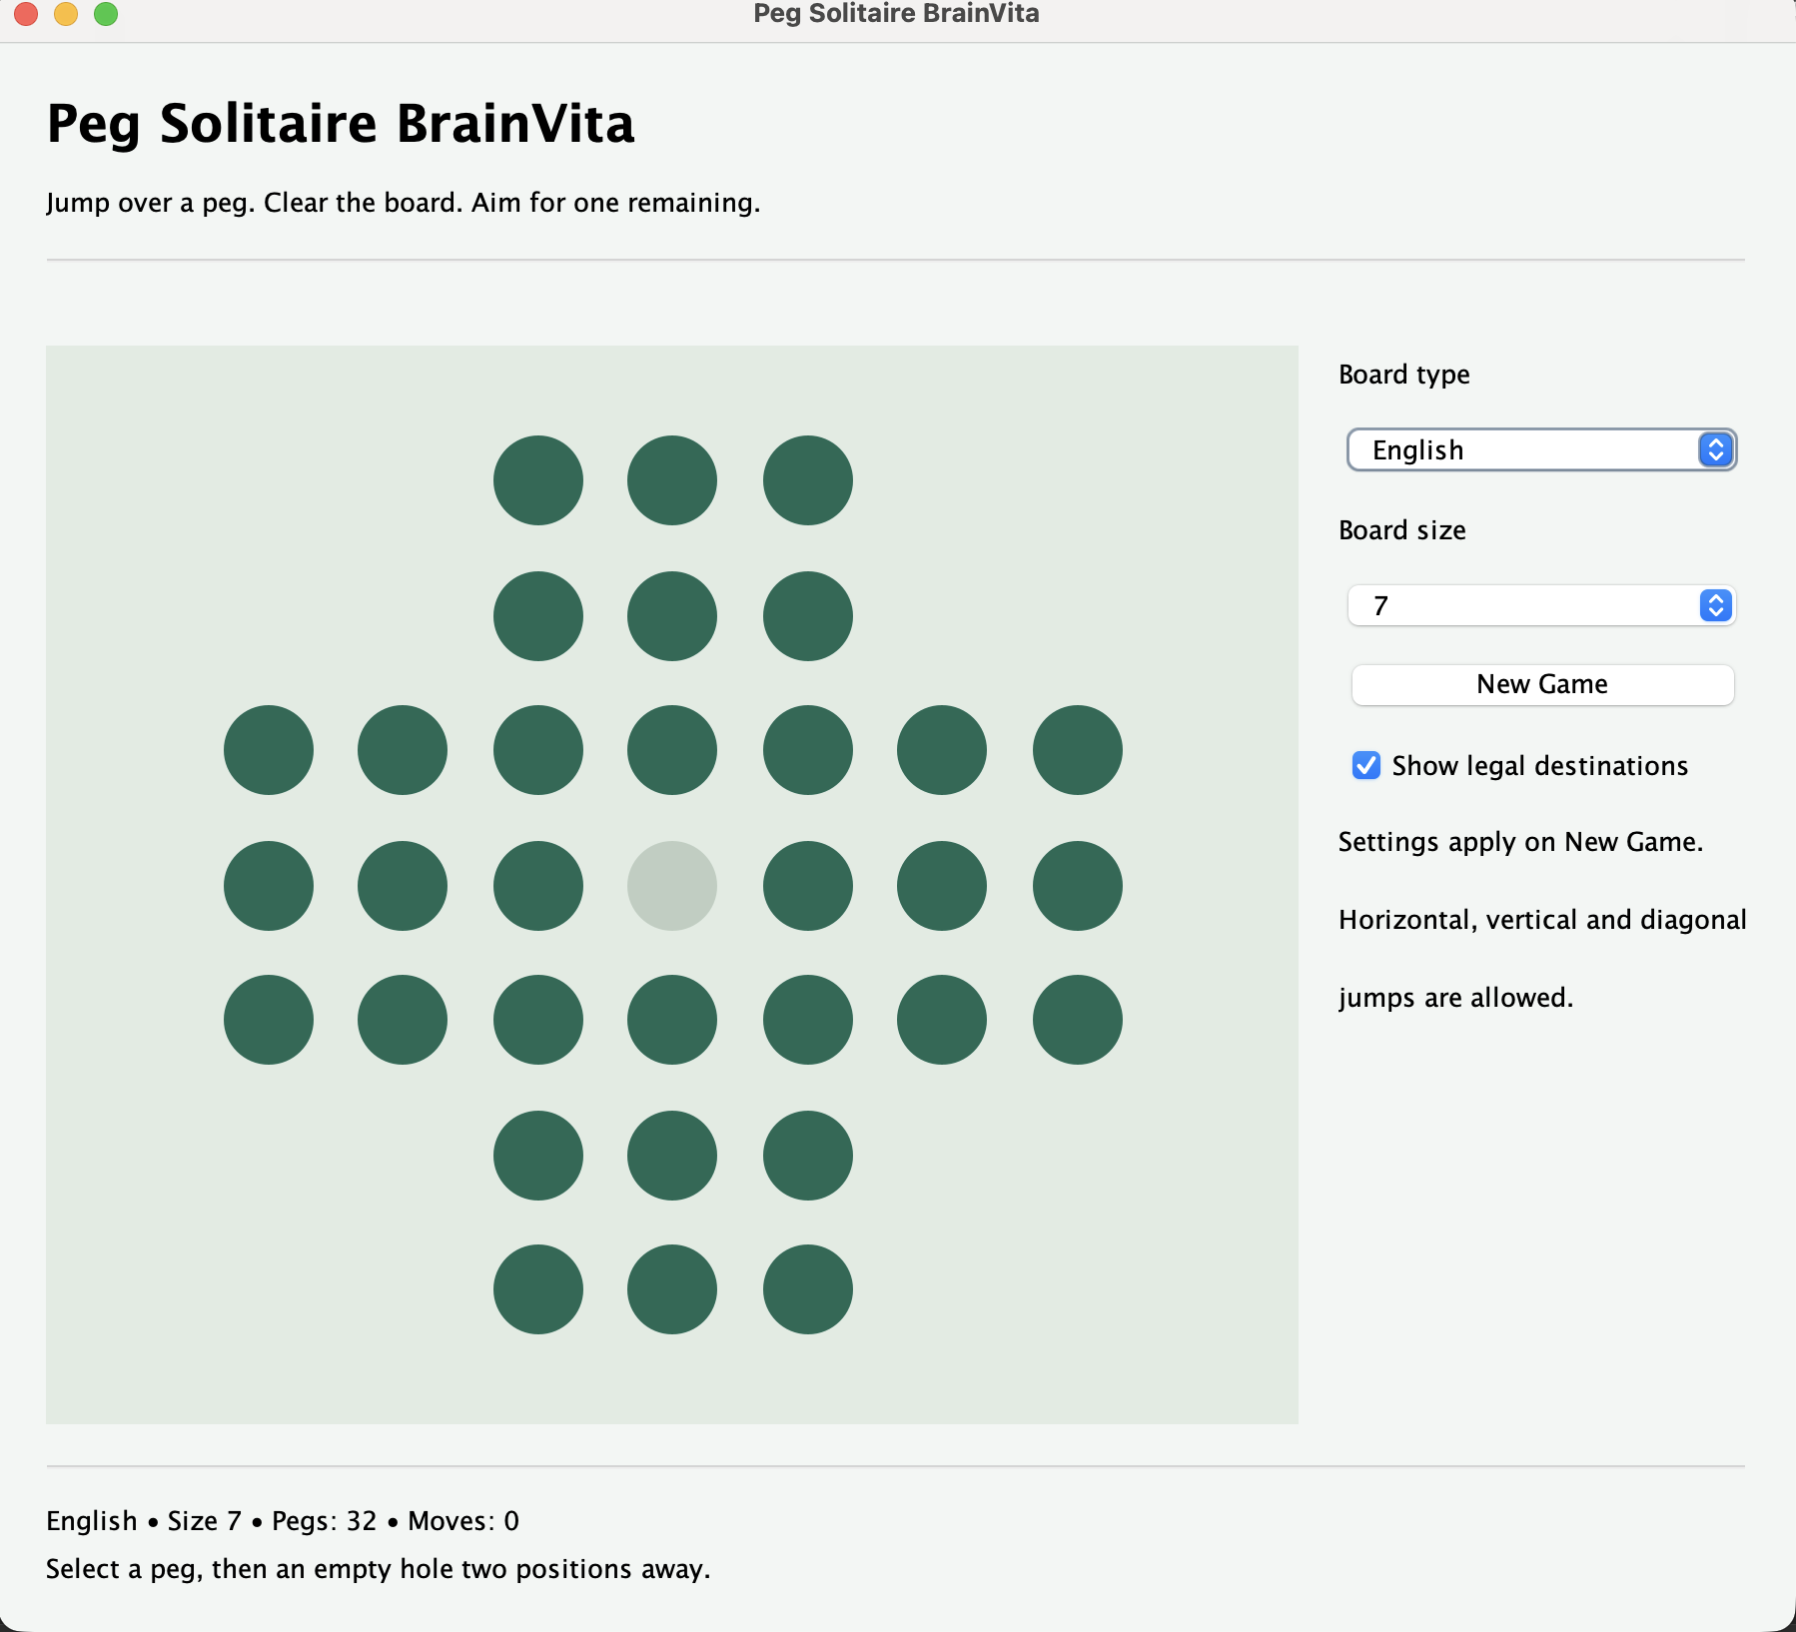
Figure 2. The running Sprint 2 game starts English size 7 with 32 pegs, an empty center, and zero moves.

6 AI Assisted Unit Test Evidence
I used ChatGPT to draft two JUnit tests and then checked both answers against the actual public API. The first is a regression test for the existing New Game behavior and uses Diamond only as an already-supported board choice; it is not presented as new Sprint 2 functionality. The second directly supports acceptance criterion 1.2 by confirming that an invalid move leaves every board cell and both counters unchanged. The first response contained incorrect method names, so I supplied the exact API and refined the answer before running the complete test suite.
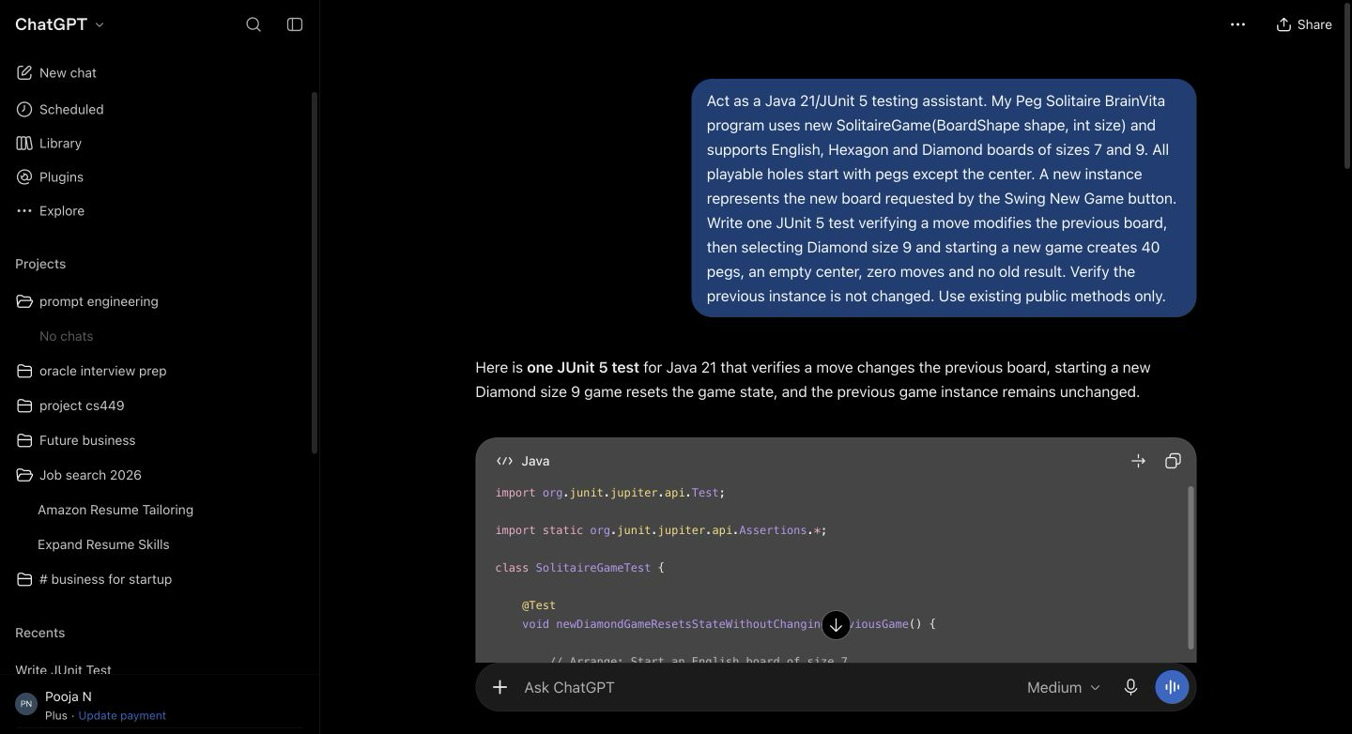
Figure 3. First ChatGPT prompt and the beginning of its generated New Game test.

6.1 Error Found and Corrected
ChatGPT's first answer used BoardShape.ENGLISH, BoardShape.DIAMOND, getPegCount(), getMoveCount(), getResult(), and move(int, int, int, int). Those names do not exist in my code. I corrected the answer by providing the actual constructors and methods: new BoardShape.English(), new BoardShape.Diamond(), pegCount(), moveCount(), result(), and move(Move). The revised test uses the real API.
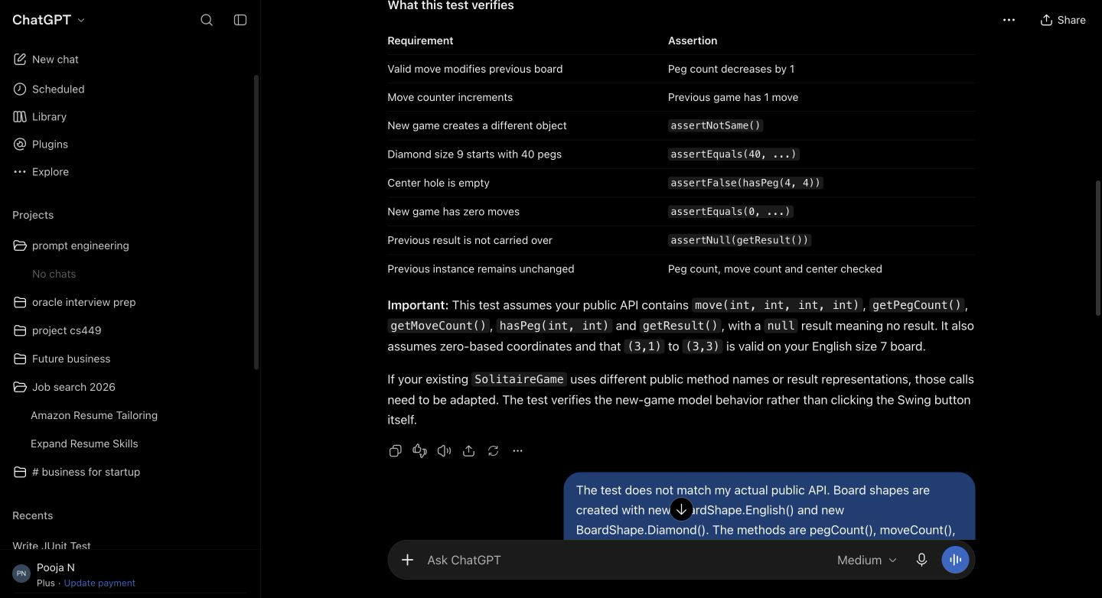
Figure 4. I identified the API errors and asked ChatGPT to rewrite the first test with the exact public methods.

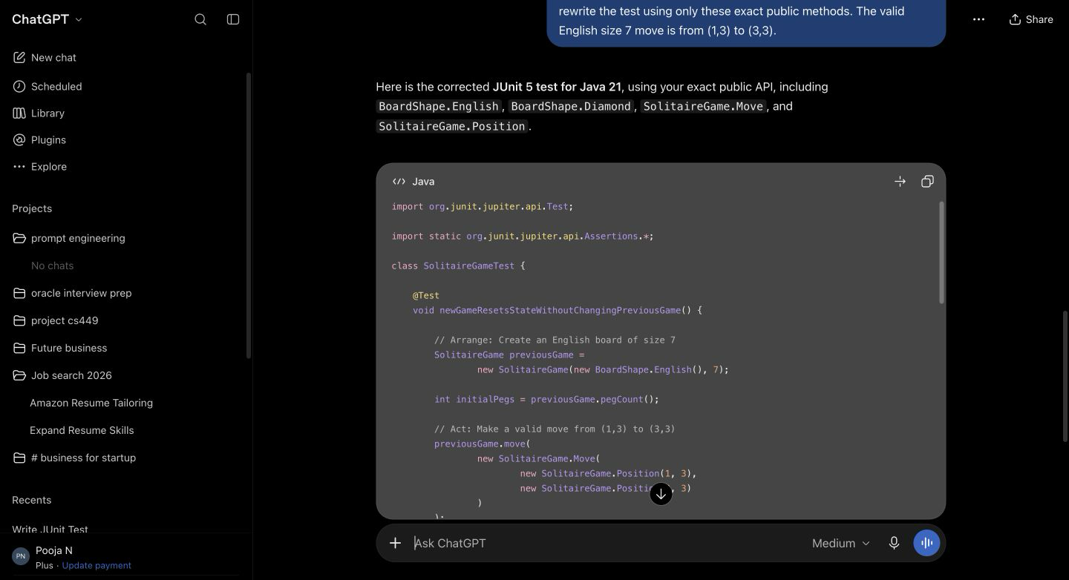
Figure 5. ChatGPT's revised answer uses the project's actual BoardShape, Move, Position, and counter APIs.

6.2 Second AI Generated Test
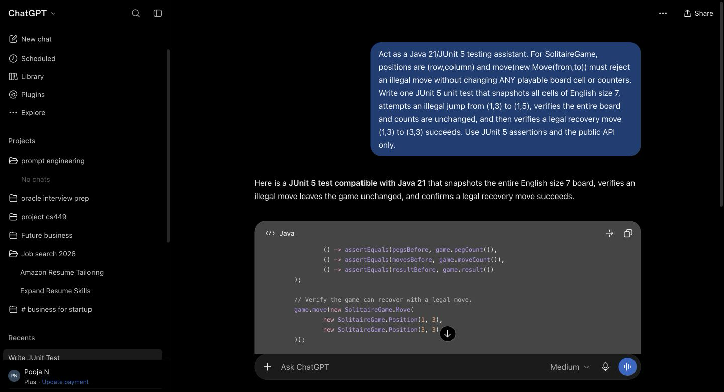
Figure 6. Second ChatGPT prompt for invalid-move state preservation and legal recovery.

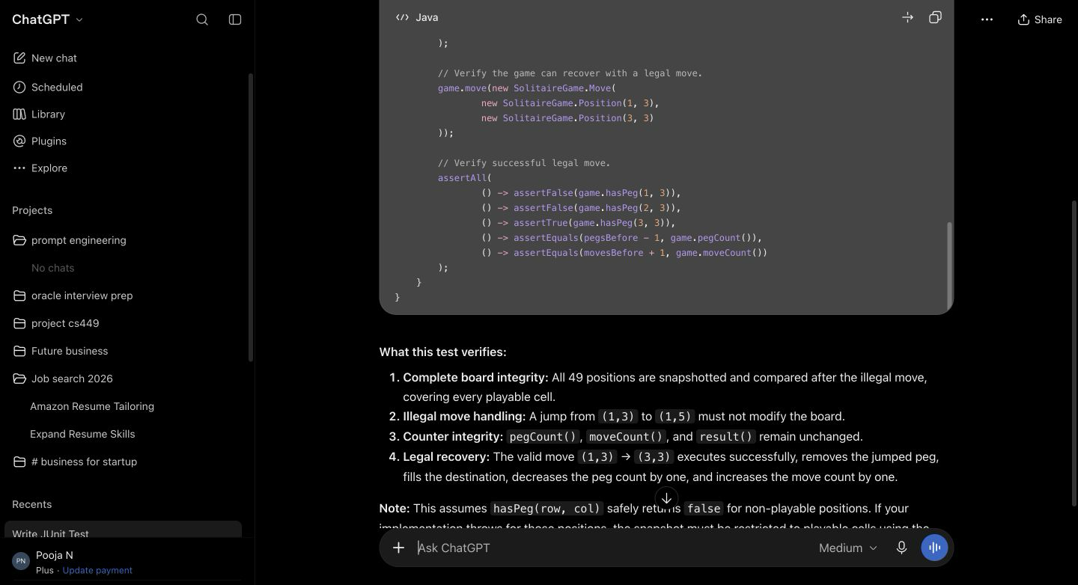
Figure 7. The second answer checks every board cell, the counters, and the legal recovery move.

